Coil Experts

[Multi-Axials Coils]

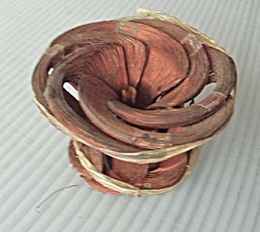
http://www.harmoniouspalette.com/
http://www.harmoniouspalette.com/multi-axial-coils-1980s.html

